Vision Australia Information library service

Using the VA Connect App
VA Connect Instructions 2017 - Version 1.2.4
Vision Australia Information Library Service
1300 654 656
library@visionaustralia.org

Table of Contents
- About the Vision Australia Connect App 3
- Accessibility 3
- Login 3
- Introduction 4
- Main Screen 4
  - Bookshelf 6
  - Subscriptions 6
  - Podcasts 7
  - Messages 7
  - Return Title 8
  - Download and Delete Download 8
  - Search 9
- Player 9
  - Audio Player 9
  - Text Player 12
- Player settings 14
  - Sleep Timer 15
  - Bookmark 15
  - Where am I? 15
- Contents 15
- Title Information 16
- App Settings 16
- For More Information 16

About the Vision Australia Connect App
The Vision Australia Connect app allows you to read titles that are available through i-access®, the online library of Vision Australia’s Accessible Information Service (AIS).
The app is able to play all audio and text content such as books, newspapers and magazines. You can stream or download the title to listen to at any time.
This version incorporates TTS, therefore it will read text books and newspapers available through i-access®.
The app is available for devices using iOS 9 and above (iPhone, iPad & iPod Touch) and Android 4 and above (Smartphone and Tablet).
To be able to use this app you have to be a registered member of the Vision Australia Library. If you are not a member, contact the Vision Australia Library on 1300 654 656 or email library@visionaustralia.org
Back to contents

Accessibility
The app is accessible using VoiceOver (iOS) or Talkback (Android). In Android, the best accessibility is provided by Android 4.3 and above.
Back to contents

Login
When you first open the app a login window is presented where you can enter your i-access® account name and password.
Upon logging into i-access® your details are automatically used to login next time. If your login fails for any reason, the login window is presented again with your previously used username but without your password filled in.
If you are logging in for the first time, you will be asked to agree to the Library’s Terms and conditions before continuing. To agree, select the Agree button at the bottom of the screen.
You can log in using different account details by selecting the ‘Change login details’ option in App Settings. However, to permanently change your password, you must do so from the i-access® web site.
If your login details are changed on the i-access® website, the app will present the login window again for you to fill in.
Back to contents

Introduction
When you log in it will connect you to the Vision Australia i-access® library to access your personal bookshelf. If you have previously logged in, the list of titles on your bookshelf is stored locally in the app. This allows you to read books you have downloaded.
This locally stored bookshelf list is synchronised with the online bookshelf each time you log in. While the app is connecting you will hear a series of beeps and a long beep when connected.
By default, the app will try to connect to the online service using Wi-Fi when your device has an active Wi-Fi connection. When your device is using a mobile internet connection (e.g. 3G) it will only connect to i-access® if you choose to allow it to. You can change this in App Settings. You will be notified if your device loses Wi-Fi connection.
Back to contents

Main Screen
The Vision Australia Connect app starts in the bookshelf screen. This screen contains four tabs on the bottom and a Search and ‘More’ buttons on the top right corner.
The first tab shows your bookshelf, the second shows your subscriptions, the third shows podcasts and the fourth shows any messages from Vision Australia.
The More button is located in the top right corner of the screen. It provides several options including App settings, update bookshelf and change login.
The More button, depicted below, is represented by 3 horizontal bars.
The Search button is also located next to this in the top right corner, it allows you to select and add content to the bookshelf.
The Search button, depicted below, is represented by 3 superposed squares and with a plus symbol on top.
Your bookshelf will be shown by default. When selecting the subscriptions tab your list of subscriptions will be displayed. When selecting the Messages tab, any messages sent to you from Vision Australia will be displayed.
For each title in your bookshelf, you can see if it is New or when you first opened it, and whether the title has been downloaded or is available to read online.
Downloaded titles can be read without an internet connection.
The app will connect to the online service regularly and synchronize your bookshelf and subscriptions as a background task if you are connected to the internet.
You can also choose to manually update the bookshelf through the More button and then select Update Bookshelf.
Back to contents

Bookshelf
The bookshelf button, depicted below, is represented by the image of a closed hard cover book with the word Books written under it.
The bookshelf is a list containing titles you can read. Titles can be added to the list from the i-access® website http://i-accessonline.visionaustralia.org, by contacting the Library or by using the Search function of the app.
When you select a title from the bookshelf it will be opened in a new Player screen.
A long press on a title shows you several options:
- Book detail information (see Title Information).
- Return the selected book
- Download the selected book if it hasn’t been previously downloaded
- Delete it from your device when downloaded
- Close the menu
Back to contents

Subscriptions
The Subscriptions button, depicted below, is represented by the image of a partially open magazine with the word Subscriptions written under it.
The subscriptions screen shows a list of titles such as magazines and newspapers you are subscribed to. Selecting a subscription opens the title in the player screen.
The app incorporates TTS, therefore it will read text content such as the daily newspapers available through i-access®.
Back to contents

Podcasts
The Podcasts button, depicted below, is represented by the image of a stick figure or an i with two half circles on its head with the word Podcasts written under it.
The podcasts screen shows a list of Podcasts and web Vision Australia Radio Stations you are subscribed to. Selecting a Podcast or Vision Australia Radio Station opens it in the player screen.
Please note only limited navigability is available in this format and Radio content consumes more bandwidth than typical books and magazines.
Back to contents

Messages
The Messages button, depicted below, is represented by the image of an italic i superposed on a circle with the word Messages written under it.
The Messages screen displays a list of important messages from Vision Australia, such as book expiration, maintenance times and other relevant information.
Please note this list will be displayed in text format and only read out loud when VoiceOver (iOS) or Talkback (Android) is enabled.
Back to contents

Return Title
You can remove a title from your bookshelf, to do this, tap-and-hold the title and choose ‘Return title’ from the options.
As soon as a title is returned you will receive a confirmation message and your bookshelf is refreshed.
Returning a title is also possible from the Title information screen. Individual subscriptions cannot be returned. Subscription editions are automatically updated as soon as a new edition is available. You can cancel a Subscription using the app.
Back to contents

Download and Delete Download
A title can be downloaded to your device so that it can be read offline, to do this tap-and-hold the title and choose ‘Start downloading’. If a title is already downloading, a ‘Cancel download’ option is available.
If the selected title was previously downloaded, you can delete it by selecting ‘Delete download’. This is useful for freeing up internal storage space.
Back to contents

Search
Use the search button to search for books by Keyword, Title or Author or you can search for, newspapers, magazines, podcasts and online Vision Australia radio stations to subscribe to.
To add an item to your bookshelf, tap the title in the search results and select Order. When the loan is confirmed you can either select back to search results to continue searching or select back to bookshelf to play the book you have chosen.
To subscribe to a newspaper, magazine or podcast, tap the title in the search results and select Subscribe. When the subscription is confirmed, select back to search results to continue searching.
Select the Subscriptions or Podcasts tab to access available issues.
Back to contents

Player
By default Audio titles are played using the Audio Player, while content which contains text, such as newspapers, can be switched between the Audio Player and the Text player depending on the user preference.
Your selection of Audio or text player is then remembered and used as a default for all other books which contain text.

Audio Player
The Audio Player contains large buttons used to navigate the selected title.
To the top left corner is the Bookshelf button followed by the title of the item and the Contents button to the top right corner.
The current heading of the title is displayed next, followed by a large navigation level button and a small player settings button that looks like a spanner and screwdriver to the right of it.
At the centre of the app are: the Previous and Next buttons, used to skip to the next navigation point, depending on the Navigation Level button setting.
Finally, at the bottom of the screen are: a small sleep timer button to the left, represented by an analogue alarm clock, a large Play/Pause button in the centre represented by the play or pause symbols and a small Bookmark button to the right which looks like a bookmark token.
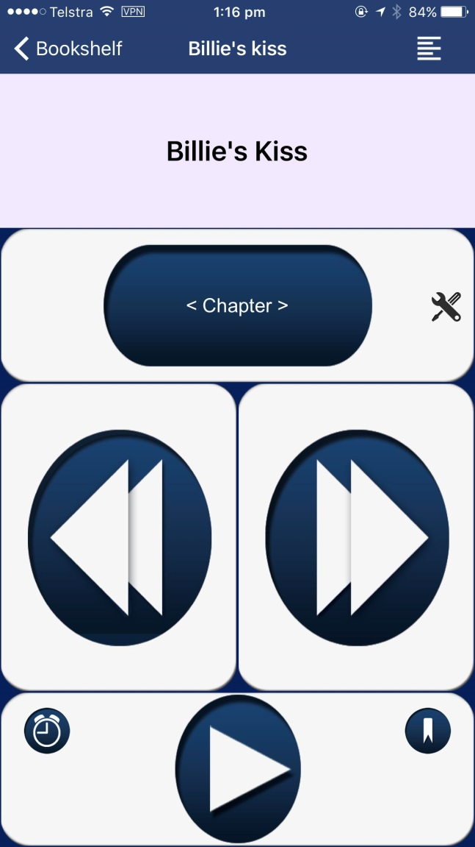
Next button
Contents button
Return to Bookshelf
Player settings button
Bookmark
Sleep Timer
Previous button
Navigation level button

Play/Pause Button

The Player screen contains the following buttons:
- Back button
Returns you to the Bookshelf.
- Contents button
This button located in the top right corner shows the contents of the title (see Contents). You can select an item from here to read.
- Text/Audio player switch button
This button located in the top right corner shows allows you to switch between the standard audio player and full text mode, this is available only for DAISY text books such as Newspapers. This button is only present when the title has text content.
- Navigation level button
Selects how you want to navigate the title. You can choose to navigate by chapter levels, page (when available) or time jump. The time jump size (in seconds) can be set from the App Settings or Player Settings screen.
- Player settings button
On the right side of Navigation level button is a Player Settings button that allows you to change the speed and time jump for this title only.
- Previous button
Selects the previous navigation point in the title, or hold this button to rewind the audio.
- Next button
Selects the next navigation point in the title, or hold this button to fast forward the audio.
- Play/Pause button
Toggles between play and pause. Hold this button to create a bookmark at the current reading position in the title.
- Sleep timer
On the left side of the Play button is the Sleep Timer button.
- Bookmark
On the right side of the Play button is Bookmark button.
When closing the player the last read position is automatically stored.

Text Player
The Text player is only available for titles that contain a full text based structure; it primarily displays the full text content for the title while highlighting in yellow the text section that is currently being played.
To the top left corner is the Return to bookshelf button, labelled as Back, followed by the title of the item in the centre and to the right corner are the Text/Audio switch button which looks like a speaker, a Player Setting button which looks like a spanner and screwdriver and a Contents button which looks like a several long and short horizontal lines.
The current heading of the title is displayed next, followed by the text content for that heading. Note that you may tap the individual text paragraph at any time in order to play back that section of text.
On the bottom of the app is the main navigation panel, the buttons in order from left to right are:
- The navigation level button, which looks like a round circle displaying H1, H2, etc depending on the selected navigation level.
- The Previous button, which looks like an arrow to the left, the Play/Pause button which looks like the symbol for play or pause and the next button which looks like an arrow to the right.
- The Sleep Timer button, which looks like an analogue alarm clock.
- The Bookmark button to the right, which looks like a bookmark token.
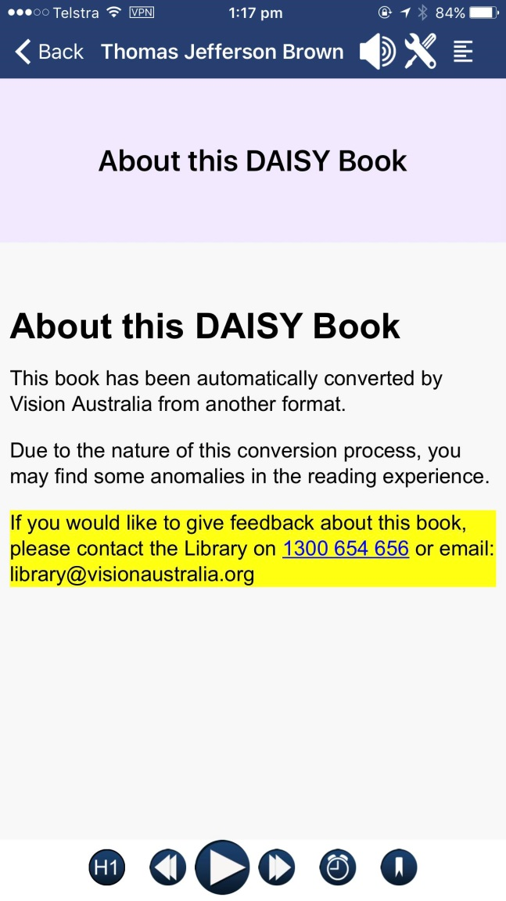
Text content with highlighting
Contents Button
Player Settings Button
Text/Audio player switch Button
Return to Bookshelf

Navigation level button
Bookmark
Sleep Timer
Next button
Previous button
Play/Pause Button

The Player screen contains the following buttons:
- Back button
Returns you to the Bookshelf.
- Contents button
This button located in the top right corner shows the contents of the title (see Contents). You can select an item from here to read.

- Text/Audio player switch button
This button located in the top right corner shows allows you to switch between the standard audio player and full text mode, this is available only for DAISY text books such as Newspapers.
- Navigation level button
Selects how you want to navigate the title. You can choose to navigate by chapter levels, page (when available) or time jump. The time jump size (in seconds) can be set from the App Settings or Player Settings screen.
- Player settings button
On the right side of Navigation level button is a Player Settings button that allows you to change the speed and time jump for this title only.
- Previous button
Selects the previous navigation point in the title, or hold this button to rewind the audio.
- Next button
Selects the next navigation point in the title, or hold this button to fast forward the audio.
- Play/Pause button
Toggles between play and pause. Hold this button to create a bookmark at the current reading position in the title.
- Sleep timer
On the left side of the Play button is the Sleep Timer button.
- Bookmark
On the right side of the Play button is Bookmark button.
When closing the player the last read position is automatically stored.
Back to contents

Player Settings
Select the Player settings button in the player to change the Playback rate, Time jump and Navigation level (if the title has multiple heading levels) for the title you have selected.
Back to contents

Sleep Timer
The sleep timer is off by default. You can set the sleep timer at 15, 30, 45 or 60 minutes. When you set the sleep timer to your preferred time it will be activated as soon as you enter play mode.
If you do not touch any of the buttons in the player during the chosen time, you will hear a tone. If you shake the device within 20 seconds of this tone, the title will continue playing. If you do not touch a button or shake the device within 20 seconds of the tone, the title will stop playing and the reading position is stored automatically.
Back to contents

Bookmark
You can place a bookmark at any time by selecting the bookmark button. Tap-and-hold the bookmark button to bring up a list of bookmarks you have created. Select a bookmark from this list to read from that position.
Back to contents

Where Am I?
By tapping the title heading in the Player window, you will see a ‘pop-up’ screen that shows your current position in the title and total book duration.
Select ‘Ok’ to close the ‘pop-up’ screen.
Back to contents

Contents
This window presents the content of the chosen title displayed as a list of chapters, pages (if available) and any bookmarks you have created.
By selecting a chapter, page or bookmark from this list, the player will start playing from that position in the title.
To delete a bookmark, tap-and-hold the bookmark list item and confirm.
If the title contains any text, this will be displayed.
Back to contents

Title Information
You can tap-and-hold a title to view the Title information. The Title information window presents details about the title such as Author, Publisher, Edition, ISBN, file size and playback duration. Also an image of the title is presented (if available) and a play button to play a preview (if available).
You can also Like or Dislike a title from within this window.
Back to contents

App Settings
Select the More button located in the top right corner of the screen and then select App settings from the options to add or change login details, select a font type and font size, and select the time jump size for navigation.
There is also a Refresh bookshelf button.
Back to contents

For More Information
Please review the instructions in this guide until you feel comfortable with using the features of the app.
For more information contact the Vision Australia Library on
1300 654 656 or email library@visionaustralia.org
End of document.

