i-access Kiosk

Getting Started

November 2023

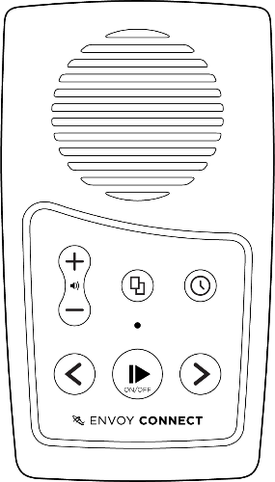

i-access Kiosk – Getting Started

What’s New?
i-access Kiosk software allows you to download titles from the Vision Australia online Library to your Envoy Connect player or computer.
1. 'Eject' button to allow safe disconnection of the player after downloading content.
2. Support for the USB-C version of the Envoy Connect player.
3. Support for long file names and large file sizes in some DAISY books.
4. Updated User Guide.

Important Information
Before choosing the Automatic Player Loading mode, please read the i-access Kiosk User Guide (this mode always removes all titles off your bookshelf as well as your player).
Note that the first time you run Kiosk, the screen that displays the titles on your Envoy Connect player (or computer) may be empty.
If this occurs, select the Next button to display the titles that are on your online bookshelf to download.
The next time you run Kiosk, the titles that have been downloaded to the player or computer will be displayed.

How to Use
Run i-access Kiosk.
With your player turned off, plug it into the computer using the supplied USB data cable.
If you wish to download to your computer, select the Cancel button to return to the main screen where you can change the device type in the File/Options menu.
Kiosk may ask for your library Username and Password.
Once you are logged in, you will be prompted to select the titles that you want to remove and new titles that you want to download.
If you choose to download to the computer, titles will be downloaded into a folder on your desktop called 'i-access Kiosk Content'.
More information can be found in the User Guide in the Help menu.

Contact and Support
i-access Kiosk software will automatically update from time to time.
If you do not have a library account, or for any other assistance, please call the Library on 1300 654 656, or email: library@visionaustralia.org.
End of document

