PATHWAY LITE
User Guide

November 2022

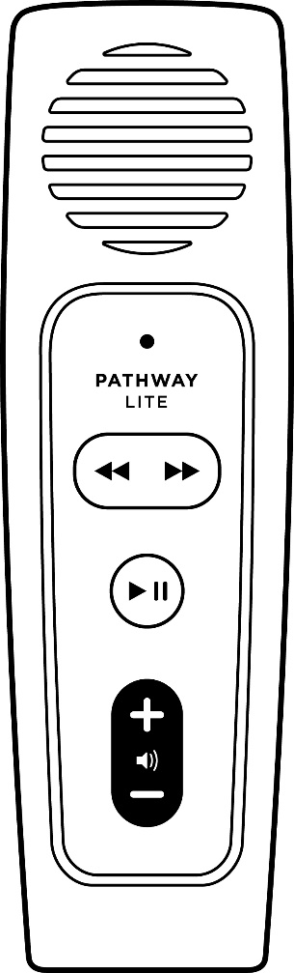

Pathway Lite Player
Pathway Lite Image

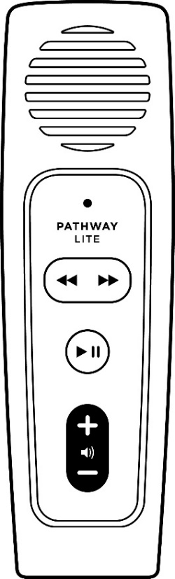
Speaker
Forward & Back
Volume
Power
& Play
LED

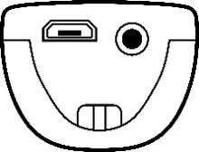
Micro USB
Headphones

Player Description:
On the front face of the Pathway Player is the speaker. Below that is the keypad with raised buttons. At the top of the keypad is the Forward and Back buttons separated by a raised line. In the middle is the round Power and Play button. At the bottom of the keypad is the Volume Up and Down buttons.
Underneath the Player is the micro USB charging port on the left and the headphone socket on the right.
On the back of the Player is the battery compartment containing a rechargeable battery.

Before You Begin:
Speaker (Front): Note that the internal speaker has a small magnet inside. Avoid placing the Player close to objects that could be affected by magnetism.
Stereo Headphone Jack (Underneath, Right): Plug headphones or external speaker into the bottom right 3.5mm audio jack. This will mute the speaker.
Micro USB Port (Underneath, Left): This port is for charging only.
Charging: When shipped, the battery may only be partially charged. Please fully charge the Player before the first use. To charge the Player, use a USB cable to plug the Player into a computer or a USB Wall Charger (not supplied) for about 2 hours. The LED will remain on while charging.
Ensure the micro USB plug is inserted into the player correctly with the two small ‘prongs’ on the plug facing down. Do not use excessive force; it will insert easily the right way around.
The LED will blink while charging. The LED will stop blinking when the player is fully charged.
The rechargeable battery will provide up to 12 hours playback time.
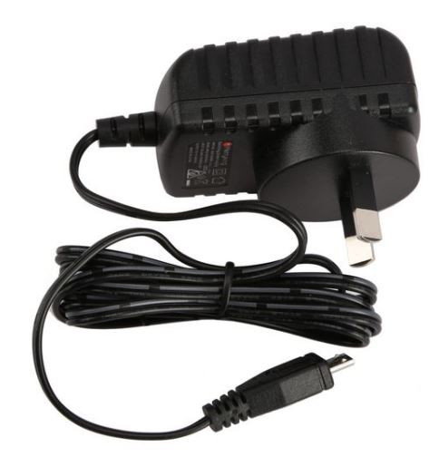
Suitable USB Wall Chargers:
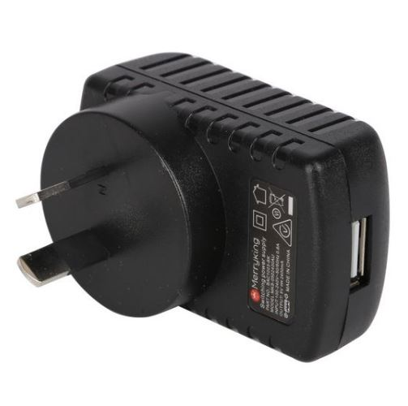
Micro USB Plug
USB Slot

Image 1: Charger with USB slot (use a separate USB cable).
Image 2: Charger with inbuilt cable with micro USB plug.

Battery Options: If you are unable to recharge the battery for any reason, you can temporarily replace the rechargeable battery with a standard (disposable) AA battery.
To open the battery compartment, undo the safety screw at the bottom of the battery cover.
Note the orientation of the battery. To insert the battery, place the negative (flat) terminal onto the lower spring, then, gently press down on the positive end of the battery to slide it in at the top.
WARNING: Take care when handling batteries and keep out of reach of children.

How to Use the Pathway Lite:

Definitions:
- Press: means to briefly, but firmly, press the button down and then release it immediately.
- Press and Hold: means to firmly press the button down and then continue to hold it for a period (e.g. press and hold the button for 3 seconds).

Power and Play Button (Middle):
- Power On: Press and hold for 3 seconds. Release the button when you hear the beep and the LED turns on. The title will start playing from the bookmarked position.
- Play/Pause: Press the button to pause playback. The LED will blink. The Player will remember your reading position. Press again to resume playback.
- Power Off: The Player will turn itself off after 5 minutes when playback is paused. You can also press and hold the button for 2 seconds to turn it off manually at any time. A double beep will sound.
Note: When you reach the end of the book, playback will continue from the start of the book.

Back and Forward Buttons (Top):
When playing a book:
- Back: Press the Back button to skip to the previous heading/chapter. If you are at the start of the book, it will ‘scroll’ around to the last heading/chapter of the book.
- Forward: Press the Forward button to skip to the next heading/chapter. If you are at the end of the book, it will ‘scroll’ around to the first heading/chapter of the book.
Note: You can press the forward or back button in quick succession to skip quickly. For example, if you click 5 times, playback will resume after skipping 5 Chapters.
Note: Vision Australia inserts a tone at the start of the book to assist in locating the beginning of the book.
Note: The Back and Forward buttons will not operate when playback is paused.
- Rewind/Fast-Forward: Press and hold the forward or back buttons to move through the audio in 15 second increments. A beep will sound to indicate that you are moving through the audio file. You can release the button at any time and playback will resume.

Volume Up/Down Buttons (Bottom):
- Volume Up: Press the upper button to increase volume. Press and hold to increase volume rapidly.
- Volume Down: Press the lower button to decrease volume. Press and hold to decrease volume rapidly.
Note: If the player is paused, a beep will indicate the level of volume as you adjust it. A double beep will sound when you reach minimum or maximum volume.
Note: It is not possible to turn the volume off completely.

Additional Features:
Volume Memory: The Player will remember your volume setting, even if the Player is turned off.
Bookmark: The Player will automatically remember where you stop playback, even when the Player is turned off.
Auto Power Off: If playback is paused for more than 5 minutes, the Player will bookmark the current reading position and turn itself off. This saves battery life and avoids the need to turn off the player manually.
Low Battery Warning: When the battery capacity is getting low, the LED will blink during playback. When the battery reaches a critically low level, the Player will bookmark the current reading position and turn itself off. The LED will be on constantly if the battery is sufficiently charged.
Reset Player: You can restore the player to its ‘factory default’ settings. While playback is paused, press and hold the Back button for 2 seconds. The Player will beep 3 times and then turn itself off (additional 2 beeps). This will remove the bookmark and set volume to medium. When turned on again, the book will play from the beginning.

Troubleshooting:
Player Will Not Turn On: Ensure the battery is charged. Using a USB cable, plug the Player into an active USB port or USB Wall Charger for about 2 hours.
Test the player with a standard AA disposable battery.
If using a standard AA battery, make sure the battery has capacity. If in doubt, replace it with a new one.
Reboot: If the Player is not responding, restart the Player by Pressing and holding the Power/Play button for 10 seconds.
Cannot Play Book: Ensure the battery is fully charged. Reset the Player. Reboot the Player.
Warning Chime: If the Player encounters a problem, it will emit a warning chime (4 beeps). Reset the player. Reboot the Player.
Cannot Insert USB Cable: Ensure you are using a micro USB type-B plug. Ensure the micro USB plug is inserted correctly with the two small ‘prongs’ on the plug facing down. Do not use excessive force; it will insert easily the right way around.
If Problems Persist:
If you have any questions or comments, please contact the Vision Australia Library on 1300 654 656 or email: library@visionaustralia.org

End of document

