2023 Calendar Art Competition Entry Form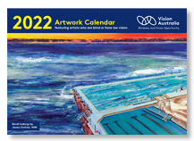 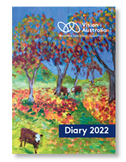
Entries are now open to all artists who are blind or have low vision for the annual Vision Australia calendar artwork competition!
It’s an opportunity to be featured in the 2023 Vision Australia large print calendars or diary. Plus, a chance to win a $300 gift card!

To enter
Please fill in this entry form online and upload images of your work
Entries close Friday 13 May 2022 at 5pm AEST

Please complete details below
Full name
Mailing address
State and postcode
Phone or mobile
Email address
Your age and closest  Vision Australia office | Age -  Closest office -
Eye condition and how long you have had it
Title of artwork #1
Date completed and medium used
Title of artwork #2
Date completed and medium used

Conditions of entry
- Artwork must be an original painting or drawing and appropriate for a decorative wall calendar
- 1-2 pieces of artwork can be submitted per artist
- Artwork must have been created within the last 12 months
- Artwork must be suitable to be reproduced (printed) in an A3 landscape format. The calendar size is L 440 mm x H 297 mm
- The competition is open to all ages
- Submissions must be high quality, high resolution, digital image/s
- Vision Australia is not responsible for the photography of any artwork
- Entry is via email only to artworkcompetition@visionaustralia.org
- The entries will be assessed by a panel of Vision Australia staff
- The judges’ decision is final and no correspondence will be entered into
- Entries close on Friday 7th May 2022 at 5pm AEST
- All successful applicants will be contacted by phone or email
- Winning artists will be asked to sign a consent form which allows Vision Australia to use the selected photographs for a period of two years for marketing purposes.
- Artists may be requested to be interviewed by the media for publicity purposes. Vision Australia does not take, keep, own or buy the original artworks.
- The successful entries, as determined by Vision Australia, will receive a special recognition certificate and a gift card to the value of $300.
- Please email your completed form and attach your digital, high res images of your artwork to: artworkcompetition@visionaustralia.org

