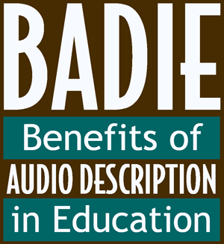

Top Tips for Writing a Great Review!

Need some tips on what makes for good audio description? Use these basic guidelines:
1. Accurate: There must be no errors in word selection, pronunciation, diction, or enunciation.
2. Prioritised: Content essential to the intended learning and enjoyment outcomes is of primary importance.
3. Consistent: Both the description content and the voicing should match the style, tone, and pace of the program.
4. Appropriate: Consider the intended audience, be objective, and seek simplicity and succinctness.
5. Equal: Equal access requires that the meaning and intention of the program be conveyed.

Here are some tips on how to write an effective review:
1. Keep it short: 300 words maximum.
Please focus on what it was about the audio description that was helpful or how it did not assist you in understanding or appreciating the film, play or exhibition. If the audio description was helpful, tell us which specific parts of the description gave you the most vivid sense of what was happening in the film. How did the audio description make you feel? How did it help you learn? Which description did you like best, and which did you not like? Why?
Read the grand-prize essays from the winner of the original BADIE competition. Learn and be inspired by these winners, but use your own words and be creative!
2. Write in the present tense.
For example: "The main character of the film is called" or "when the film starts, he or she does this or that."
3. Make it fun!
Just because you're writing a review doesn't mean it can't be fun to read. Make it as entertaining as possible for your readers.
4. Dish the dirt.
Say exactly what you think (but say it well). Tell the reader whether you liked or disliked but be certain to say why. The judges want to hear your personal opinion and how you support your view.
5. Don’t tell the story.
You only have 300 words, so focus on what you think was most important about your experience viewing a video with audio description.
6. Be a reporter!
If you can, take notes while you're experiencing the audio description (write down memorable quotes, significant moments, etc.).
7. Make time.
The best reviews are written while the content is still fresh in the mind, so do try to get your ideas down as soon as possible after experiencing the AD.
8. Edit!
Don't forget to reread your audio description review, edit it, then prepare a finished version.
9. No cheating!
Make sure your work is original (must be written in your own words) and not copied from another source in any way.
10. Meet your deadline.
Even the most famous writers in the world have to get their work done on time, so don't forget your deadline!
If you have any questions please email BADIEAU@Visionaustralia.org

Good Luck!!!
[End of Document]

