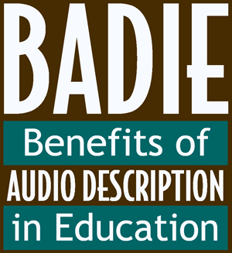
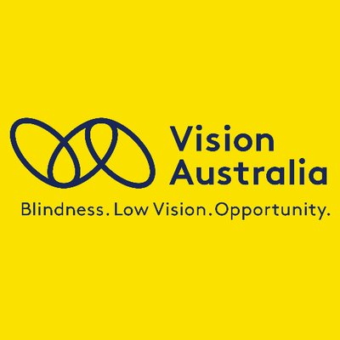

Notes for educators, service providers and parents

The Benefits of Audio Description in Education initiative (BADIE) recognises the pivotal role that Audio-visual content plays in education, culture and society and the importance of audio description as a tool for access.
Vision Australia is thrilled to partner with the American Council for the Blind and the Audio Description project to bring the BADIE initiative to Australia, to nurture and reward critical engagement with audio description.

What is audio description?
Audio Description is visual information conveyed through words. It translates things that are visible into things that you can hear. With Audio Description you don’t need to see in order to understand what is happening because all the important visual information is translated into the spoken word. RNIB has created this 2-minute video to explain audio description: https://www.youtube.com/watch?v=i_GrYOruY7w
With the recent inclusion of audio description on the ABC and SBS (not to mention dvds, cinemas and streaming platforms), young Australians have more opportunities than ever to access content through Audio Description.
This is a great opportunity for your child to develop skills of critical thinking, listening and writing, and be rewarded for it!
All they have to do is experience a piece of audio description (in school, on a streaming platform, at the cinema, in the theatre, in a gallery…) and write a 300-word review of the audio description.
All entrants will receive a certificate of participation and the winners will receive prizes and have their entries shared with the original BADIE committee in America and audio description providers in Australia, to ensure that their voice has the chance to impact the ongoing development of audio description.
You can find a list of places you can find Audio Described content on the BADIE-AU page of the Vision Australia website:
(https://www.visionaustralia.com.au/community/events/badie-au)
If you are planning on including audio-visual content in the upcoming academic year, this is a great opportunity to ensure you choose content that has an audio described version. Many key literary texts have been translated into film, and many of these dvds are available with audio description.
There’s even evidence that Audio Description can support learners who do not have a visual impairment, by boosting literacy and language development, writing and listening skills – and recognising that some learners absorb information better using auditory channels.
Whilst this competition is aimed at young people who are blind or have low vision, this could provide a great learning opportunity for the whole class to learn about different types of access solutions and develop their critical skills.
Please refer to the BADIE-AU page of the Vision Australia website for details on how to enter, closing dates and where you can find audio described content.
If you have any questions please email BADIEAU@Visionaustralia.org

[End of Doc]

