Skills to support people with vision loss
Everyone appreciates a helping hand from time to time. It’s important to remember that we all have preferences for what we want help with and how that help is given.
People who are blind or who have low vision are no different. Help from strangers, friends and family members can often make life a little easier. However, it’s very important to respect a person’s boundaries and independence, and help in ways that support dignity.
If you’ve never met someone who is blind or who has low vision before, it’s natural for you to be uncertain. But all you have to do is start by asking.
“Excuse me. Would you like a hand? How can I help?”
Vision Australia is Australia’s leading provider of services and support for people who are blind or have low vision. We currently support over 26,000 people nationally and, as the experts, we can help you develop the skills to assist someone with vision loss in ways that work for you both. This guide is a great starting point to help you expand your knowledge and skills around the small things that can make big differences for someone with vision loss.
Three easy first steps:
Approach
If you think a person might need a hand – walk up, say hello and tell them who you are. “Hi. My name is…”
Ask
Remember that not everyone who is blind or has low vision will want help, so say something like “would you like a hand with anything or are you ok?”
Assist
Listen to their response and help accordingly.

Everyday tips to help someone who is blind or has low vision:
- Always identify yourself by saying your name and let the person know who else is present. Let them know when you’re leaving or moving away.
- Say their name so they know you’re speaking to them.
- Use everyday language – no need to avoid words like ‘look’ and ‘see’, they are part of everyone’s vocabulary.
- Speak and behave naturally – continue using your normal body language because your body position and facial expressions affect your tone of voice.
- Shake their hand if it’s offered.
- Talk about what is happening visually, giving useful details. Describe images, such as ‘this picture shows several ducks in a row’.
- In dangerous situations say ‘STOP’ (rather than ‘look out’).
- Always say if you are going to move objects or furniture.
- Don’t fill drinks to the brim.
- When giving directions or instructions, be specific. Try not to point or say “over there.” Instead, direct the person to their left or right, for example, and use general measurements – ‘the chair is about two metres to your left’.
- Close doors or open them fully – never leave them ajar.

Guiding someone who is blind or has low vision
Sometimes people who are blind or have low vision find it useful to be guided by another person. One way to do this safely and efficiently is to use sighted guide techniques. Not all people with vision loss use these methods, so it is important to ask what (if any) specific assistance they require. Here are some techniques you may find useful:

Ask the person if they need assistance. If they do, touch the back of their hand with the back of yours.
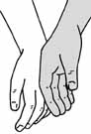
They can then find your elbow and hold your arm lightly just above the elbow. You can relax your arm down by your side.
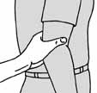

Walking
When you start walking, make sure you are half a step ahead and slightly to the side. Walk at a pace that is comfortable for both of you. Look ahead for obstacles at foot level, head height and to the side.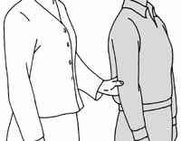

Steps and staircases
Stop at the first step and tell the person you are guiding whether the steps go up or down. If necessary, change sides so the person you are guiding can use the handrail. Start walking when they are ready and stay one step ahead. Stop when you both reach the end of the stairs and tell the person they are at the top or bottom.
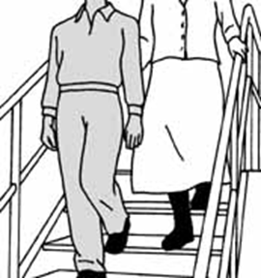

Seating
Explain which way the chair is facing and where it is located in relation to the rest of the room. Then walk up and place the hand of your guiding arm on the chair and explain which part of the chair you are touching. The person you are guiding can then move their hand down your arm to locate the chair and seat themselves. 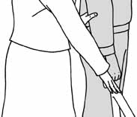

Behaving correctly around a Seeing Eye Dog
A Seeing Eye Dog is a highly trained assistant that helps their handler navigate their surroundings. The handler and dog must work as a team, and stay focussed in order to be safe. It’s important to take your cue from the Seeing Eye Dog’s handler. The following are some helpful tips on ways to interact with someone who has a Seeing Eye Dog.
- Speak directly to the handler when offering help.
- Don’t avoid offering assistance to a Seeing Eye Dog handler.
- Position yourself slightly behind the right shoulder of the handler when walking with them.
- Walk about one metre ahead if the handler is instructing their dog to ‘follow’ you, and continue talking to the owner so they know where you are
- Make the handler aware if their dog looks unwell or is behaving unusually.
- Never distract, talk to, feed or touch a working dog (in or out of harness) unless you have the owner’s permission.
- Feel free to ask for permission and follow the owner’s instructions about how to interact with the dog if the owner says it’s OK.

Written communication for someone who is blind or who has low vision
Provide written material in the format the person prefers, such as large print, audio, braille or an accessible electronic document.

Support for carers and family members
Adjusting to and finding out when a person you love has vision loss can be difficult. As they move into their new way of going about their daily tasks, it can be a challenge to know how best to support them
If you are supporting someone who has vision loss, it can be good to talk to others who are as well. Vision Australia offers a range of social support services. You can chat about how you are doing, learn what other people are trying, find out about opportunities and services, and make new supportive connections.
There are many more ways to help someone who has low vision or is blind. Talk to us to find out more about developing your support skills.

Vision Australia is the leading national provider of vision loss support.
Phone 1300 84 74 66
Vision Australia has 28 metro and regional centres around Australia. Call us or visit our website to find the one closest to you.

Find out more
visionaustralia.org
Email: info@visionaustralia.org
facebook.com/VisionAustralia
twitter.com/visionaustralia
Vision Australia acknowledges the support of state and commonwealth governments. For full acknowledgements visit www.visionaustralia.org/gvtfunding

