Daisybox

Quick Start Guide

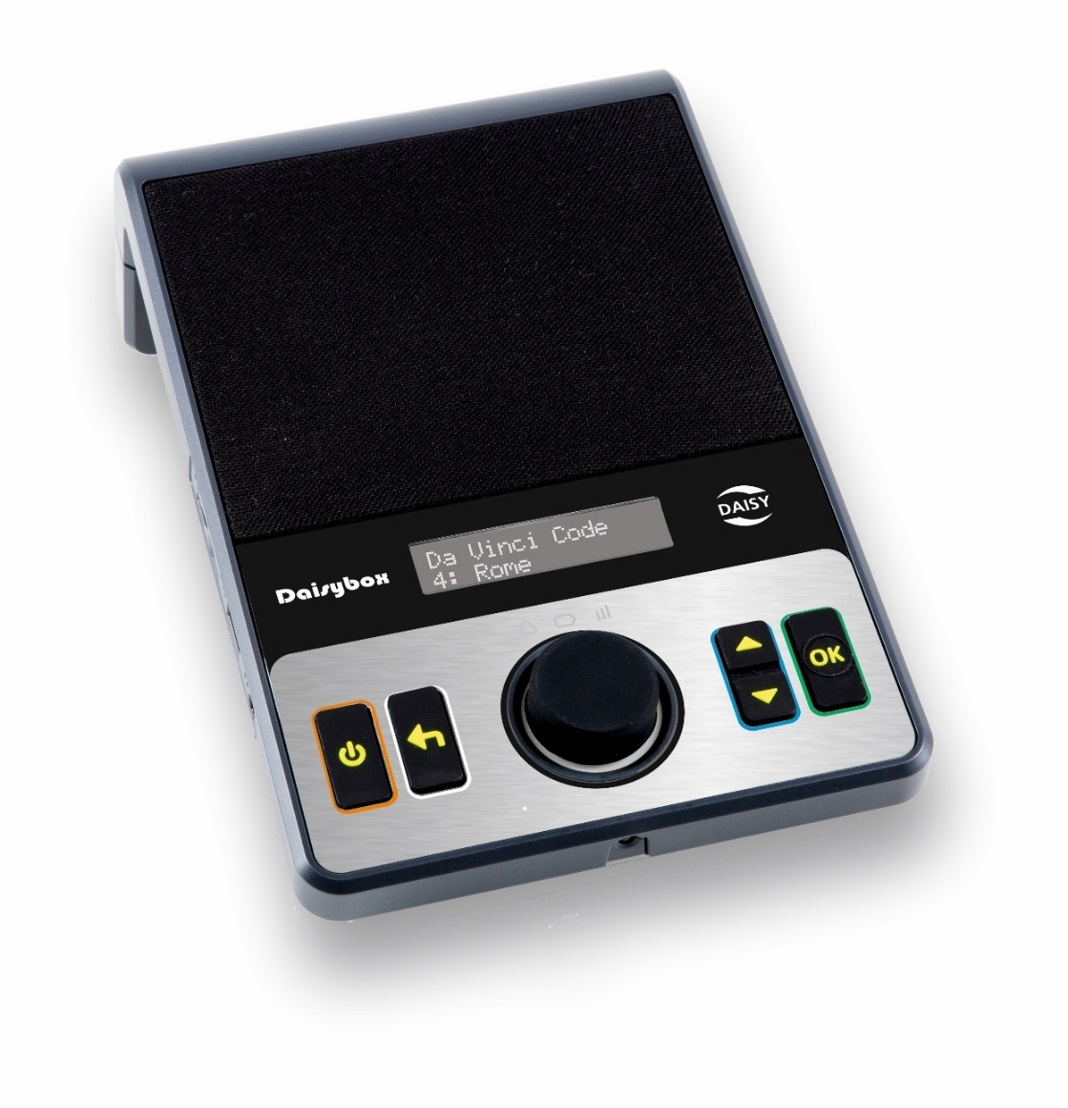

Note: This User Guide applies to player version 25.11.13.

Player Description:
The speaker is located on the upper front face of the player. Below the speaker grill is a status display in the center. On the lower front of the player is a large Volume Control in the middle and two rectangular tactile buttons on each side of this.

On the left side of the player is the headphone jack, USB port and SD card slot.

On the back of the player is a carry handle, DC power input, network port and RCA audio output.

Underneath the player is the rechargeable battery compartment. Inside the battery compartment is another USB port.

Button Description:
Power button: The Power button is located on the lower far left on the players face. Press it momentarily to turn the player on. Press it for 3 seconds to turn the player off.

Back button: The Back button is located between the Power button and the Volume Control knob. The Back button is used to go back to the bookshelf or to exit from the menu.

Volume Control & Play/Pause knob: The Volume Control knob is in the lower center of the player. Turn the knob to adjust the volume. Press it to Play or Pause.

Note, press the Volume Control knob when the player is off to check the battery level and other information.

Up/Down button: The Up/Down button is located on the right of the Volume Control. Use the Up/Down buttons to move between books on bookshelf or menu items, and fast forward or rewind during playback.

OK button: The Ok button is located on the lower far right on the players face. The OK button is used for confirming selection of a book on the bookshelf or menu item.

Operating the Player:
- Plug in the supplied AC power adapter to fully charge the player on first use.

- The player can be operated using the power adapter or by the internal rechargeable battery for approximately 7 hours.

- The player will turn itself off after 5 minutes when playback is paused.

Charging:
- Always maintain some battery charge. When the player announces “Battery 5%”, plug in the supplied AC adapter to recharge.

Note, battery warnings are announced at 5% to 0%. It is important not to let it get to 0%.

- It takes approximately 4 hrs to fully charge a flat battery.

Playing a Book:
- Press the Power button to turn the player on and wait for the player to connect to the online service. When connected, the player will announce “Bookshelf” and the User Guide or last played book.

- If no title is announced, press the Up/Down buttons to select a book from the bookshelf.

- Press the Volume Control knob (Play) to begin playing the book when you hear the book title announced.

- Press the Volume Control knob again to pause playback.

Rewind/Fast Forward:
- While playing a book, press the Up/Down buttons to skip forward or back to the next chapter/section.

- While playing a book, press and hold the Up/Down buttons to fast forward or rewind within a chapter/section.

Selecting a Book from the Bookshelf:
- While a book is playing, press the Back button once to go back to the bookshelf.

- When playback is paused, press the Back button twice to go back to the bookshelf.

- Press the Up/Down buttons to choose a new book from the bookshelf.

- Press the Volume Control knob to select and play the book.

Information:
- While playing a book, press and hold the Volume Control knob for at least 3 seconds to hear the time, battery level and other book related information. You can also select Information from the menu.

Menu:
The menu includes features such as Sleep timer and Audio settings that you may want to access when playing a book including Table of contents, Sleep timer, Return book and Audio settings.

- To enter the Menu, press and hold the Ok button for at least 3 seconds.

Note, the menu items will be different depending on whether you are in the bookshelf or have selected a book.

- Press the Up/Down buttons to scroll through menu items.

- Press the Ok button to select a menu item.

- Press the Back button to exit the menu.

Note, press the Back button at any time to exit a menu without selecting. You may need to press Back again to go back several steps.

Table of Contents:
This allows you to select a specific section within a book, newspaper or magazine.

- Select Table of Contents from the menu list.

- Press the Up/Down buttons to browse the list of sections (e.g. chapters) of the DAISY book.

- Press OK to select and begin playback.

- Press the Back button to resume playback of the book without making a selection.

Sleep Timer:
- Select Sleep Timer from the menu list.

- Press the Up/Down buttons to select the ‘sleep time’ period.

- Press OK to confirm and resume playback.

Note, after pressing OK, the player will begin playback automatically.

- Press the Back button to resume playback of the book without making a selection.

Return Book:
This will ‘return’ the book to the library, remove it from your bookshelf and make space for a new book.

- Select the book you want to remove from the bookshelf before entering the menu.

- Select Return This Book from the menu list.

- Press the OK button to return the book, then press Ok again to confirm.

- Press the Back button at any time to resume playback of the book without returning it.

Audio Settings:
- Select Device Configuration from the menu list.

- Select the Audio Settings item from this menu list.

- Use the Up/Down buttons to scroll through the list that includes speed and tone.

- Press the OK button to select an item. Use the Up/Down buttons to change the setting for an item, then press the Ok button to confirm.

- Press the Back button to go back without making a change to any setting and to exit the menu.

Remote Control:
The remote-control (supplied) allows you to control the player using dedicated buttons.

For the remote control to work, the infrared (IR) receiver on the front of the player must not be obstructed and have line of sight from the IR transmitter on the top of the remote control.

The battery compartment is on the back. Slide the lid down to open it to insert two 1.5V AAA batteries (supplied).

Button Description:
Power: The round Power button is located on the top right.

- Press it momentarily to turn the player on.

- Press and hold it for 3 seconds to turn the player off.

Menu: The round Menu button is located on the top left.

- Press it to go to the players menu at any time.

- Press it again to exit the menu.

Volume, Tone and Speed: The Volume, Tone and Speed Up/Down buttons are located together in a row below the Power and Menu buttons. The volume is on the left, the tone in the middle and speed on the right.

- Press the upper button to increase the setting and press the lower button to decrease the setting of each function.

Information: The Information button is located halfway down the remote control on the left below the Volume button.

- When playing, press Information to hear the time, battery level and other book related information.

- Press Back at any time to exit Information.

Sleep timer: The Sleep button is located on the right of the Information button in the middle of the remote control.

- Press it to set a 30-minute sleep timer.

- Press it again to turn the sleep timer off.

Spare button: On the right of the Sleep timer button in the middle of the remote control is a button that has no function.

Navigation buttons: On the lower half of the remote control are four up/down/left/right arrow buttons arranged in a ‘diamond’ configuration. In the middle of the arrow buttons is a round OK button. Below the arrow buttons is a round Back button. These buttons are used to play, pause and navigate books and menu items.

OK: The round OK button is in the middle of the four arrow buttons.

- When you turn the player on or in the bookshelf, press the OK button to begin playback.

- When playing, press OK to pause playback.

- Press OK to select and confirm a menu item.

Back: The round Back button is located on the bottom left of the remote control below the Left arrow button.

- If playback is paused, press the Back button to resume playback.

- If playing, press Back to go back to the bookshelf.

- Press Back to exit a menu item.

Up/Down: The Up/Down buttons are above and below the middle OK button.

- When on the bookshelf, press the Up/Down buttons to step through the titles on the bookshelf.

- When playing, press Up/Down to skip to the previous/next section.

- When in the Information or player menu, press the Up/Down buttons to step through the menu items.

Left/Right: The Left/Right buttons are on either side of the OK button.

- When playing, press and hold the Left/Right buttons to rewind or fast-forward within the current section/chapter.

- To resume playback, release the Left/Right buttons and momentarily press the Left/Right button again.

- When in the Information or player menu, press the Left/Right buttons to step through the menu items.

Support:
If you would like further assistance or have any questions, please contact the Vision Australia library via phone or email:
Ph: 1300 654 656
Email: visionaustralia.library@visionaustralia.org

End of document

