Daisybox

User Guide

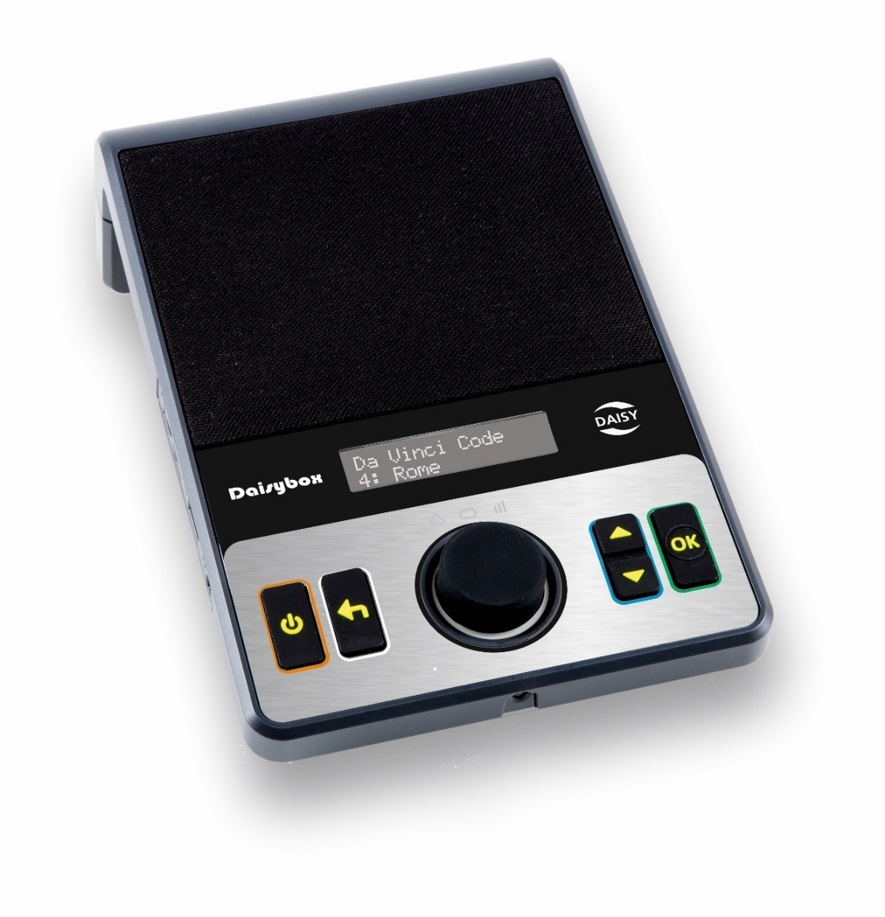
Note: This User Guide applies to player version 25.11.13.

Table of Contents:
Player Description: 3
Button Description: 3
Operating the Player: 5
Charging: 6
Network Connection: 6
Power On/Off: 6
Playing a Book: 7
Rewind/Fast Forward: 7
Selecting a Book from the Bookshelf: 8
Information: 11
Player Menu: 11
How to Check the Player Version: 15
How to Check the Serial Number: 16
Using External Media: 17
Player Software Updates: 20
Support: 21
Appendix 1 - Menus: 22
Appendix 2 - Player Setup: 27
Appendix 3 - Remote Control: 32

Player Description:
The speaker is located on the upper front face of the player. Below the speaker grill is a status display in the center. On the lower front of the player is a large Volume Control in the middle and two rectangular tactile buttons on each side of this.

On the left side of the player is the headphone jack, USB port and SD card slot.

On the back of the player is a carry handle, DC power input, network port and RCA audio output.

Underneath the player is the rechargeable battery compartment. Inside the battery compartment is another USB port.

Button Description:
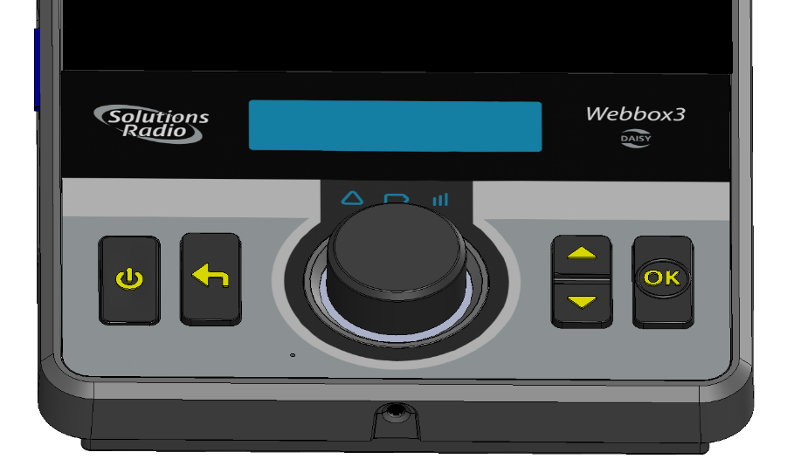
Play/Stop
Volume
Down/FFW
Ok
Up/Rew
Back
Power
IR receiver
Power button: The Power on/off button is located on the lower far left on the players face. Press it momentarily to turn the player on. Press and hold it for 3 seconds to turn the player off.

Back button: The Back button is located between the Power button and the Volume Control knob. The Back button is used to go back to bookshelf or to exit from the menu.

Volume Control & Play/Pause knob: The Volume Control knob is in the lower center. Turn the knob to adjust volume. Press the knob to Play or Pause.

Note, press the Volume Control knob when the player is off to check the battery level and other information.

Note, there is no audible indication when adjusting the volume when the player is paused. Be aware of this when starting playback.

Up/Down button: The Up/Down button is located on the right of the Volume Control. Use the Up/Down buttons to move between books on bookshelf or menu items, and fast forward or rewind during playback.

OK button: The OK button is located on the lower far right on the players face. The OK button is used for confirming selection of a book on the bookshelf or menu item.

Remote Control IR Receiver: The infrared (IR) light receiver is located on the front edge of the player. It allows a remote control (supplied) to control the player using dedicated buttons. For more information see Appendix 3 - Remote Control.

Operating the Player:
- Plug in the supplied AC power adapter to fully charge the player on first use.

- The player can be operated using the power adapter or by the internal rechargeable battery.

- The player will turn itself off after 5 minutes when playback is paused avoiding the need to manually turn off and save battery power.

- If you connect headphones, the speaker will switch itself off.

- The player will remember your volume level and other settings when you turn the player off.

- The small status display is not needed to use the player. It provides the same information that is voiced by the player such as the title of the book and menu items.

Charging:
- Always maintain some battery charge. When the player announces “Battery 5%”, plug in the supplied AC adapter to recharge.

Note, battery warnings are announced at 5% to 0%. It is important not to let it get to 0%.

- It takes approximately 4 hrs to fully charge a flat battery.

- A fully charged battery will provide approximately 7 hours of playback time.

Network Connection:
- The network (internet) and user account must be setup on the player before you can connect to the Vision Australia library. For more information on network setup see Appendix 2 - Setup.

- To access your Vision Australia library online bookshelf, you need to be a registered member of the Vision Australia library service. Contact the Library on 1300 654 656, or email: library@visionaustralia.org

Power On/Off:
- Press the Power button to turn player on and wait for the player to connect to the online service. When connected, the player will announce “Bookshelf” and the User Guide or last played book.

- Press and hold the Power button for 3 seconds to turn the player off.

Playing a Book:
- If no title is announced, press the Up/Down buttons to select a book from the bookshelf.

- Press the Volume Control knob (play) to begin playing the book when you hear the book title announced.

- Press the Volume Control knob again to pause playback.

- When a book has finished playing, the player will announce “Finished reading ‘X’ (Title of book)”. Playback will stop and revert to the bookshelf.

Rewind/Fast Forward:
- While playing a book, momentarily press the Up/Down buttons to skip forward or back to the next chapter/section.

- While playing a book, press and hold the Up/Down buttons to fast forward or rewind within a chapter/section. The player will move forward or back in one-minute intervals. It will announce the elapsed time within the section and resume playback when you release the button.

- When fast forwarding/rewinding, if you reach the end of the section, the player will announce “End” and pause. Release the Up/Down button, skip to the next section by momentarily pressing Up/Down and then press and hold Up/Down again to continue.

Note, the Up/Down buttons are inactive when playback is paused.

Selecting a Book from the Bookshelf:
- While a book is playing, press the Back button once to go back to the bookshelf.

- When playback is paused, press the Back button twice to go back to the bookshelf (a single press will resume playback).

- Press the Up/Down buttons to choose a new book from the bookshelf.

- Press the Volume Control knob to select and play the book.

Vision Australia Radio:
The Vision Australia Radio (VAR) item is always listed on the bookshelf. Select it to listen to VAR at any time. You can start and stop VAR streaming, but other playback functions are disabled.

Announcements:
The Announcements item is always listed on the bookshelf. Select it to listen to any messages sent to you from Vision Australia, e.g. a service announcement.

Search:
The Search item is always listed on the bookshelf. Select it to search the library catalogue for a new book, magazine, newspaper or podcast.

- When prompted, press the Up or Down buttons to search by Keyword, book title or author. Press OK to select the option.

- Press the Up or Down buttons to scroll and choose characters. Press OK to enter each character.

Note, characters can be deleted by pressing the Back button.

- To begin a search, press the Down button to scroll to end of the character list until you hear “Finished”. Press OK to select ‘Finished’ and begin searching. It may take several minutes to return results depending on the search term.

Note, to make it easier to enter search terms, it is possible to use a USB keyboard plugged into the USB port. See heading: Options for Entering Characters.

Note, press Back at any time to go back without searching. You may need to press Back again to go back several steps.

- When the search in completed, the player will announce how many books it has found. Press Up/Down to hear the list of found books. Press OK to select a book.

- Press Up/Down to choose ‘Add Book’. Press OK to add the selected book to your bookshelf. You can also choose ‘Information’.

- Press the Back button once to do another search, or two times to go back to the bookshelf to select an existing book to play.

- To play a new book you have added, turn the player off and on again to update the bookshelf.

Information:
- When the player is off, press the Volume Control knob to hear the time and check the battery level.

- While playing a book, press and hold the Volume Control knob for at least 3 seconds to hear the time, battery level and other book related information. You can also select Information from the menu.

Note, press the Up/Down buttons to step through the information items. Press Back at any time to return to the book.

Player Menu:
The players menu allows you to access information and configure all of the settings related to the player and selected book.

Note, the menu items will be different depending on whether you are in the bookshelf or have selected a book from the bookshelf or external media. To access all menu items related to a book, first select the book.

The menu contains features that you may want to access when playing a book, including:

  - Table of Contents
  - Sleep Timer
  - Download Book
  - Return Book
  - Audio Settings

A detailed menu list is described in Appendix 1 - Menus.

- To open the menu, press and hold the Ok button for at least 3 seconds. The menu can be opened from the bookshelf or when a book is selected.

- Press the Up/Down buttons to scroll through menu items.

- Press the Ok button to select a menu item.

- Press the Back button to exit the menu.

Note, press the Back button at any time to exit a menu without selecting. You may need to press Back again to go back several steps.

Table of Contents:
This feature is part of the menu and allows you to select a specific section within a book, newspaper or magazine.

- Enter the menu and select Table of Contents from the menu list.

- Press the Up/Down buttons to browse the list of sections (e.g. chapters) of the DAISY book.

- Press OK to select and begin playback.

- Press the Back button at any time to resume playback of the book without making a selection.

Sleep Timer:
This feature is part of the menu and allows you to choose an automated turn off time between 10 minutes and two hours.

- Enter the menu and select Sleep Timer from the menu list.

- Press the Up/Down buttons to select the ‘sleep time’ period.

- Press OK to confirm and resume playback.

Note, after pressing OK, the player will begin playback automatically.

- Press the Back button at any time to resume playback of the book without making a selection.

Download Book:
This feature is part of the menu and will download the book to external media so that you can play it at any time without network connectivity. For more information, see heading: Using External Media.

Return Book:
This feature is part of the menu and will ‘return’ the book to the library, remove it from your bookshelf and make space for a new book.

- Select the book you want to remove from the bookshelf. The book will begin playing.

- Enter the menu and select Return This Book from the menu list.

- Press the OK button to return the book, then press OK again to confirm.

- Press the Back button at any time to resume playback of the book without returning it.

Audio Settings:
This feature is part of the menu and allows you to customise the audio settings such as tone and speed.

- Enter the menu and select Device Configuration from the menu list.

- Select the Audio Settings item from this menu list.

- Use the Up/Down buttons to scroll through the following items from the Audio Settings menu list:

  - Startup Volume (Mute, Soft, Normal, Loud, Current)
  - Speed (Normal, +/- 50%)
  - Tone (Normal, +/- 30%)
  - Pitch (Normal, +/- 50%)

- Press the OK button to select an item. Use the Up/Down buttons to change the setting for an item, then press the Ok button to confirm.

- Press the Back button at any time to go back without making a change to any setting and to exit the menu.

How to Check the Player Version:
From time to time the Daisybox will update itself with new software to include new features or improvements. See heading: Player Updates.

When the player is updated, the software version will change. You can check the version of your player in the Menu.

- To enter the Menu, press and hold the OK button for 3 seconds.

- Go to the Device Status menu item using the Up/Down buttons. Press the OK button to select.

- Step through the Device Status menu items using the Up/Down buttons until the player announces “The software version is ‘X’ (Example: 25.11.13)”.

- Press the Back button several times to exit the menu.

How to Check the Serial Number:
If requesting support from Vision Australia, you may be asked for the player Serial number. The serial number is a 5-digit number on the label under the player. You can also check the Serial number of your player in the Menu.

- To enter the Menu, press and hold the OK button for 3 seconds.

- Go to the Device Status menu item using the Up/Down buttons. Press the OK button to select.

- Step through the Device Status menu items using the Up/Down buttons until the player announces “Your serial number is ‘X’ (Example: 12345)”.

- Press the Back button several times to exit the menu.

Using External Media:
It is possible to download a book to external media such as an SD card or USB memory so that you can play it at any time on a player that has not been configured or is offline (no network connectivity).

Inserting/Removing External Media:
- Insert an SD card or USB memory media into the ports on the left side of the player or the USB port inside the battery compartment (remove battery compartment cover).

- To remove external media, turn the player off and unplug the USB memory or push the SD card to eject it.

Note, turn the player off before removing external media to avoid corrupting it. If you remove the media while a book is playing, turn the player off and reinsert the media for it to be recognised and play again.

Selecting External Media:
- If external media is plugged in when you turn the player on, but you have not previously used it, the player will connect to the online bookshelf.

- To go to external media from the online bookshelf, press the Back button to go to the external SD or USB media. The player will announce “You have selected ‘X’ (USB or SD), this list contains ‘X’ (number of titles) items”.

- If you have previously played a book from the external media, the player will load that media when you turn it on and will announce the title of the last played book.

Playing a Book:
- Press the Play button to begin playing the book that is announced or press the Up/Down buttons to hear the list of books on the external media.

- Use the players controls to select and play the book in the same way as when using the online bookshelf. Example, press the Volume Control (Play) knob to Play/Pause the book and the Up/Down buttons to skip forward or back.

Download Book (menu item):
This feature is part of the players menu and will download the book to external media.

Note, the player will not download if there is no external memory present.

- Select the book you want to download from the Bookshelf before entering the menu. The book will begin playing.

- Press and hold the OK button for at least 3 seconds to open the menu.

- Select Download Book from the menu list.

- Press the OK button to select download. Download begins immediately. The player cannot be used during this time until the download has completed.

Note, do not press any buttons on the player while download is in progress. This will interrupt the download process. If this occurs, press Back two times to return to the bookshelf to select the book again.

- Once downloading has finished, the player will announce “All items have been downloaded”.

- Press the Back button two times to exit the menu and go back to the bookshelf or press it three times to exit the menu and bookshelf and go to the external media to play the downloaded book.

Removing a Book:
- Using the player, it is not possible to remove a book that has been downloaded to external media.

Note, to remove a book from external media, turn the player off before removing the media and plug the media into a computer to manage the storage and delete the book.

Return to the Online Bookshelf:
- To go back to the online bookshelf from the SD card or USB memory, stop playback and press the Back button. The player will announce “You have selected bookshelf. This list contains ‘X’ (number of titles) items”.

Note, when going back to the online bookshelf from external media the player will not resume the last book you were playing until you reselect it from the bookshelf.

Player Software Updates:
From time to time the Daisybox will update itself with new software to include new features or improvements.
If an update is available, when turning the player on it will announce “Updating” and the player will automatically install the new software. This may take several minutes.
While updating itself the player will remain silent. Do not turn the player off or attempt to use it while the update is in progress.
When the update is finished, the player will turn off and restart itself normally.

Support:
If you would like further assistance or have any questions, please contact the Vision Australia library via phone or email:
Ph: 1300 654 656
Email: visionaustralia.library@visionaustralia.org

Appendix 1 - Menus:
To open the menu, press and hold the OK button for at least 3 seconds. The menu can be opened from the bookshelf or when a book is selected.

The menu items will be different depending on whether you are in the bookshelf or have selected a book. To access all menu items related to a book, first select the book.

Menu Items:
Information | Date
Information | Battery capacity
Information | Bookshelf info (Not available when a book is selected)
Information | Book title, total, elapsed and remaining time, etc (Not available from Bookshelf)
Table of Contents | Lists the book structure (Not available from Bookshelf)
Sleep Timer | Off, 10min, 20min, 30min, 40min, 50min, 60min, 90min, 120min
Download this Book | Downloads to SD or USB memory (Not available from Bookshelf)
Return this Book | Deletes the book from SD or USB memory (Not available from Bookshelf)
Device Configuration  Device Configuration | Add Wireless Network | Search for available networks
Device Configuration  Device Configuration | Audio Settings | Startup Volume: Mute, Soft, Normal, Loud, Current
Device Configuration  Device Configuration | Audio Settings | Speed: -50 to -10, Normal, +10 to +50
Device Configuration  Device Configuration | Audio Settings | Tone: -30 to -10, Normal, +10 to +30
Device Configuration  Device Configuration | Audio Settings | Pitch: -50 to -10, Normal, +10 to +50
Device Configuration  Device Configuration | Synthetic Voice | English Lisa
Device Configuration  Device Configuration | Synthetic Voice | English Tyler
Device Configuration  Device Configuration | Advanced  Advanced | Ethernet
Device Configuration  Device Configuration | Advanced  Advanced | DHCP
Device Configuration  Device Configuration | Advanced  Advanced | IP Address
Device Configuration  Device Configuration | Advanced  Advanced | Netmask
Device Configuration  Device Configuration | Advanced  Advanced | Gateway
Device Configuration  Device Configuration | Advanced  Advanced | DNS server 1
Device Configuration  Device Configuration | Advanced  Advanced | DNS server 2
Device Configuration  Device Configuration | Wireless Network | DHCP
Device Configuration  Device Configuration | Wireless Network | IP Address
Device Configuration  Device Configuration | Wireless Network | Netmask
Device Configuration  Device Configuration | Wireless Network | Gateway
Device Configuration  Device Configuration | Wireless Network | DNS server 1
Device Configuration  Device Configuration | Wireless Network | DNS server 2
Device Configuration  Device Configuration | Power Key Delay | 0 Seconds
Device Configuration  Device Configuration | Power Key Delay | 0.5 Seconds
Device Configuration  Device Configuration | Power Key Delay | 2 Seconds
Device Status  Device Status | Summary info (Battery capacity, Ethernet, Wireless, etc)
Device Status  Device Status | Ethernet (Network info, MAC address, etc)
Device Status  Device Status | Wireless network (WiFi network info, MAC address, etc)
Device Status  Device Status | UMTS network (Only when a USB mobile broadband modem is inserted)
Device Status  Device Status | Network test (to confirm connectivity and network information)
Device Status  Device Status | Media information (SD and USB Storage)
Device Status  Device Status | Serial number ‘xxxxx’
Device Status  Device Status | Current time
Device Status  Device Status | Current date
Device Status  Device Status | Software version (Current FW version, e.g. 25.11.13)
Device Status  Device Status | Operating system (e.g. Linux 4.9.37)
Device Status  Device Status | Synthetic voice (current TTS voice, e.g. Lisa)

Reset Menu:
To access the Reset menu, with the player on, press the Reset button located inside battery compartment (remove the battery compartment cover).

Menu Items:
Reset | Reset all user settings
Reset | Remove all shortcuts and bookmarks
Reset | Remove one wireless network
Reset | Reset all network settings
Reset | Remove a specific credential (Displays the DAISY online URL)
Reset | Remove all stored credentials
Reset | Reset all settings to the factory default (Press and hold reset button, then turn power on)
Reset | Restart

Appendix 2 - Player Setup:
The internet and user account must both be setup on the player before you can access the Vision Australia Library.

The internet connection must be established before the user account settings can be entered.

Connection to the online library can be via WiFi, ethernet cable or mobile broadband modem.

WiFi:
- Turn the player on. Wait for the player to announce “Connecting to Vision Australia”.

- Press and hold the OK button for at least 3 seconds to enter the menu.

- Press the Up/Down buttons to scroll through the menu and choose ‘Device Configuration’. Press the OK button to select the menu item.

- Press Up/Down and choose ‘Add a Wireless Network’. Press the OK button to select.

The player will then search for available WiFi networks. Wait for the player to announce “Networks found”.

- When networks are found, press Up/Down to choose the desired WiFi network. Press the OK button to select. The player will announce network signal strength followed by how to enter the WiFi password.

Wait for the announcement to finish or press the Up/Down buttons at any time to begin entering the password.

- To enter the password, press Up/Down to scroll and choose characters. Press OK to enter each character.

Note, characters can be deleted by pressing the Back button.

- To save the completed password onto the player, press the Down button to scroll to end of the character list until you hear “Finished”. Press OK to select Finished and save the password.

- The player will replay the password and announce “The configuration has been added”.

- Press the Back button twice to exit menu.

Note, if unsuccessful, the player will not connect and continually announce “Connecting to Vision Australia”. In this case, repeat this procedure from Step 2.

- The player will prompt you to enter your library account username and password.

Ethernet Cable:
- Plugin the supplied ethernet cable into your network port.

- Turn the player on. Wait for the player to announce “Connecting to Vision Australia”.

- The player will prompt you to enter your library account username and password. See heading: User Account Setup.

Mobile Broadband Modem:
If WiFi or a cable internet network is not available or you want full portability, you can use a mobile (4G/5G) internet modem such as the Telstra 4GX USB modem (not supplied).

Plug the modem into the left side USB port, however, to prevent damage, it is better to route a short 20cm USB extension cable (not supplied) from the internal USB port inside the battery compartment to the rear of the player using the built-in cable channel.
Note, the internal USB port cavity may not be large enough to plug in the USB modem directly.
User Account Setup:
- The player will prompt you to enter your library account username and password.

- To enter your username, press the Up/Down buttons to scroll and choose characters. Press OK to enter each character.

Note, characters can be deleted by pressing the Back button.

- To save the completed username onto the player, press the Down button to scroll to end of the character list until you hear “Finished”. Press OK to select ‘Finished’ and save the username.

- To enter your library account password, press the Up/Down buttons to scroll and choose characters. Press OK to enter each character.

Note, characters can be deleted by pressing the Back button.

- To save the completed password onto the player, press the Down button to scroll to end of the character list until you hear “Finished”. Press OK to select ‘Finished’ and save the password.

- The player will connect to the online service. Once connected it will announce “You have selected Bookshelf”.

Note, if unsuccessful, the player will not connect and continually announce “A problem occurred during login”. In this case, repeat this procedure.

Options for Entering Characters:
When using the Up/Down buttons to enter characters it is possible to make a mistake.
Therefore, it is recommended to use a keyboard plugged into the USB port on the left side of the player.

Using the keyboard, type the characters without pressing the Enter key. When all characters are entered, press the keyboard Enter key to save the information. Voice feedback is provided as you type.

Note, characters can be deleted by pressing the Backspace key.

Appendix 3 - Remote Control:
The remote-control (supplied) allows you to control the player using dedicated buttons. This provides easy access to controls and features of the player and avoids the need to enter the player menu to find a setting.

The remote control uses infrared (IR) light to control the player. The remote-control IR transmitter is on the top edge of the remote control. The players IR receiver is on the front edge of the player.

For the remote control to work, the IR receiver on the front of the player must not be obstructed and have line of sight from the remote control.

When you press a button on the remote control, its function will be voiced by the player.

Battery Compartment: The battery compartment is on the back. Slide the lid down to open it to insert two 1.5V AAA batteries (supplied).

Button Description:
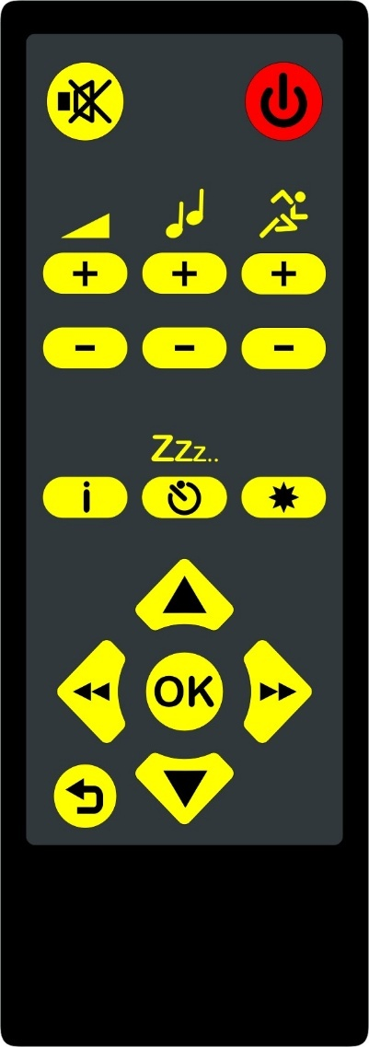
IR transmitter
Speed
Volume
Power
Back
OK
Sleep timer
Left/RW
Right/FFW
Menu
Down
Information
Tone
Up
Not used

Power: The round Power button is located on the top right.

- Press it momentarily to turn the player on.

- Press and hold it for 3 seconds to turn the player off.

Menu: The round Menu button is located on the top left.

- Press it to go to the players menu at any time.

- Press it again to exit the menu. If you press it while playing a book, playback will resume.

Note, you may need to press the Menu button more than once to go back several steps to exit the menu.

Volume, Tone and Speed: The Volume, Tone and Speed Up/Down buttons are located together in a row below the Power and Menu buttons. The volume is on the left, the tone in the middle and speed on the right.

- Press the upper button to increase the setting and press the lower button to decrease the setting of each function.

Note, there is no audible indication when adjusting the volume when playback is paused. Be aware of this when starting playback.

Information: The Information button is located halfway down the remote control on the left below the Volume button.

- When on the bookshelf, press the Information button to hear the time and battery level.

- When playing, press Information to hear the time, battery level and other book related information.

- Press Back at any time to go back the bookshelf or resume playback.

Note, you can press the Left/Right buttons to step through the information items.

Sleep timer: The Sleep button is located on the right of the Information button in the middle of the remote control.

- Press it to set a 30-minute sleep timer.

- Press it again to turn the sleep timer off.

Spare button: On the right of the Sleep timer button in the middle of the remote control is a button that has no function.

Navigation buttons: On the lower half of the remote control are four up/down/left/right arrow buttons arranged in a ‘diamond’ configuration. In the middle of the arrow buttons is a round OK button. Below the arrow buttons is a round Back button. These buttons are used to play, pause and navigate books and menu items.

OK: The round OK button is in the middle of the four arrow buttons.

- When you turn the player on, press the OK button to begin playback.

- When playing, press OK to pause playback.

- After choosing a new title on the bookshelf, press OK to select and start playback.

- When in the menu, press OK to select and confirm a menu item.

Back: The round Back button is located on the bottom left of the remote control below the Left arrow button.

- If playback is paused, press the Back button to resume playback.

- If playing, press Back to go back to the bookshelf.

- When in the Information or player menu, press Back to exit a menu item.

Note, you may need to press Back more than once to go back several steps.

Up/Down: The Up/Down buttons are above and below the middle OK button.

- When on the bookshelf, press the Up/Down buttons to step through the titles on the bookshelf.

- When playing, press Up/Down to skip to the previous/next section.

- When playback is paused, the buttons have no function.

- When in the Information or player menu, press the Up/Down buttons to step through the menu items.

Left/Right: The Left/Right buttons are on either side of the OK button.

- When playing, press and hold the Left/Right buttons to rewind or fast-forward within the current section/chapter.

- To resume playback, release the Left/Right buttons and momentarily press the Left/Right button again.

- If you fast-forward to the end of the section, the player will announce “End”. To move to the next section, momentarily press Right to resume playback and then press and hold the Right button to continue fast-forwarding.

- If you rewind to the start of the current section, the player will announce “Start”.

- When playback is paused, the buttons have no function.

- When in the Information or player menu, press the Left/Right buttons to step through the menu items.

End of document

